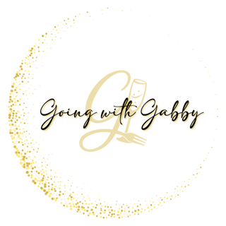
Business Name: Going with Gabby
Owner: Gabrielle Farnes
Location: Cushing, Oklahoma
Contact: 918-306-1547
P. O. Box 124
Cushing, OK 74023
gabrielle@goingwithgabby.com
Effective Date: 09/12/2025

1. General Liability Disclaimer
Going with Gabby is a home-based business operating under the Oklahoma Home Bakery Act and Cottage Food Laws. While we follow all required safety and sanitation practices, we are not liable for any adverse effects resulting from the consumption or misuse of our products.
2. Ingredients & Allergens
Our baked goods may contain or come into contact with common allergens including, but not limited to:
- Wheat (Gluten)
- Eggs
- Milk
- Soy
- Tree Nuts and Peanuts
All products are made in a private home kitchen that is not inspected by the Oklahoma State Department of Health. Cross-contamination is possible. Customers with food allergies or sensitivities should exercise discretion when purchasing.

3. Storage & Shelf Life
Customers are responsible for proper storage of baked goods once they are picked up or delivered. We are not responsible for spoilage, melting, or other issues that occur after the product leaves our care.
4. Custom Orders & Payments
Custom orders may require a non-refundable deposit. Final payment is due before or at the time of delivery/pickup. Orders must be cancelled at least 14 days in advance to receive a partial refund (if applicable).
5. Pickup & Delivery
All products are packaged securely and checked before handoff. Once the item is picked up or delivered, Going with Gabby is not liable for any damages incurred in transit or due to improper handling by the customer.
6. Oklahoma Cottage Food Law Compliance
This business is registered under the Oklahoma Home Bakery Act. All baked goods are produced in a private home that is not subject to state food safety inspections. Products are sold directly to consumers and not for resale.
7. Hold Harmless Agreement
By purchasing and consuming products from Going with Gabby, the customer agrees to hold harmless and indemnify the business and its owner from any claims, liabilities, damages, or legal actions, including those related to allergic reactions, misuse, or improper handling.

Signed:
Gabrielle Farnes
Owner, Going with Gabby
Date: 09/12/2025

